**Event Hub Integration with Postgres server.**

The below steps to Integrate EventHub with Postgres server.

1. Create of the resource group.

2. Create two Event Hubs namespace in two different regions.

3. Create an event hub for the primary namespace.

4. Assigning the authorization rules to the namespace in two different regions.

5. Enabling the Geo-Recovery by providing the details of primary and secondary namespace along with Alias name.

6. Enable the Diagnostics setting in the Postgres sever for all logs and the provide the Destination details as EventHub.

* **Resource group.**

* **Event Hub namespace in primary region.**

* **EventHub namespace in secondary region.**

* **Event Hub in primary region.**

* **Authorization policy in primary region**.

* **Authorization policy in secondary region.**

* **Setting up the Geo-Restore in primary name space region.**

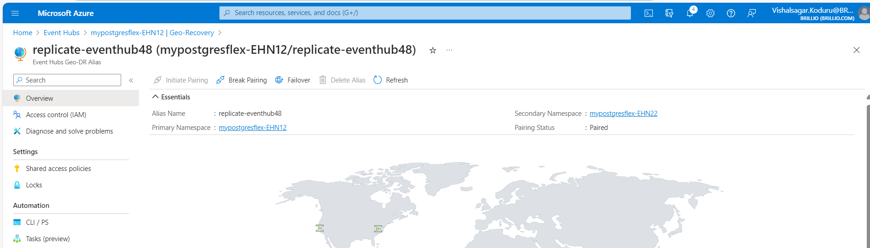

* **Enabling the EventHub in Postgres server.**

